Guide on how to enable the DJI EP SDK on S1s

Prerequisites:   
Install the RoboMaster app on a computer, and install/download ADB on your computer  
Robomaster app: https://www.dji.com/sg/downloads/softwares/robomaster-win  
ADB: https://developer.android.com/studio/releases/platform-tools

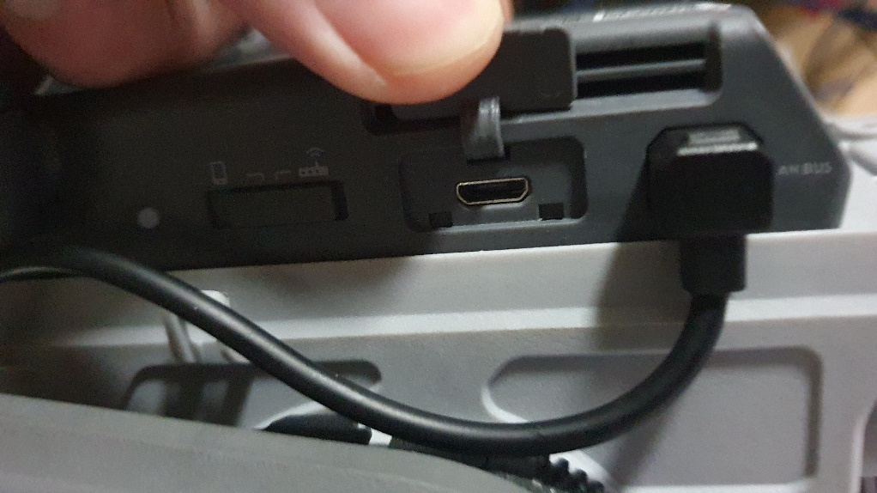Step 1) Plug in a micro USB cable into the controller module into the slot below

Step 2) Power on the S1 with a battery (the module does not turn on with USB power!)

Step 3) Launch the Robomasters app on a computer and connect to the robot. Router or direct Wifi does not matter

Step 4) Go to Lab > DIY Programming > Python and create a new file and input the code below:

def root_me(module):

    __import__=rm_define.__dict__['__builtins__']['__import__']

    return __import__(module,globals(),locals(),[],0)

builtins=root_me('builtins')

subprocess=root_me('subprocess')

proc=subprocess.Popen('/system/bin/adb_en.sh',shell=True,executable='/system/bin/sh',stdout=subprocess.PIPE,stderr=subprocess.PIPE)

Click on the play button above to execute the code on the S1

This enables Developer mode on the controller module and enables ADB access

DO NOT turn of the application yet

On Windows:

Step 5) Unzip the .zip folder containing ADB and navigate to the directory

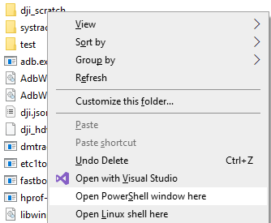Step 5.5) To check that you have done the previous steps correctly and the S1 is connected to the computer, hold shift and right click in the folder and select: open Windows Powershell

In the powershell that opens: type .\adb.exe devices  
If the S1 controller has been rooted successfully, you should see the following: 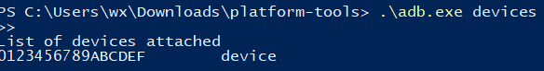  
Should there be more than 1 device, disconnect all other phones/android based devices from your computer other than the S1

Step 6) Copy the following folders directly into the directory containing ADB.exe:  
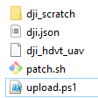

Step7) Run upload.ps1

Step 7.5) (optional) To verify that the patch has been uploaded successfully, run .\adb.exe shell in a powershell window. This gives you access to the S1 controller, the same as a control line interface for Linux. Change the directory to /data/ and verify that patch.sh is present in the controller.

Potential problems: If .\adb.exe devices shows that the device is offline, use a different micro-usb cable

On Ubuntu: (I honestly don’t know why you might be doing this in ubuntu considering that the Robomasters app is only available on windows)

Step 5) in the folder containing the 4 files, open a terminal

Step 5.5) Ensure that ADB has been installed, if not run sudo apt-get install adb  
Ensure that the S1 is connected to your computer by running adb devices  
There should only be 1 device connected. Should there be more than 1, disconnect any android based device that is currently connected to your computer other than the S1 robot.

Step 6) Run upload.sh

Step 7) ?? profit?

Extra stuff:

To edit text files in the S1 manually, run busybox vi <filename>  
This starts a vim instance :>